Data Models Objective

Based on Lego Data downloaded from Kaggle:



**Conceptual Model**

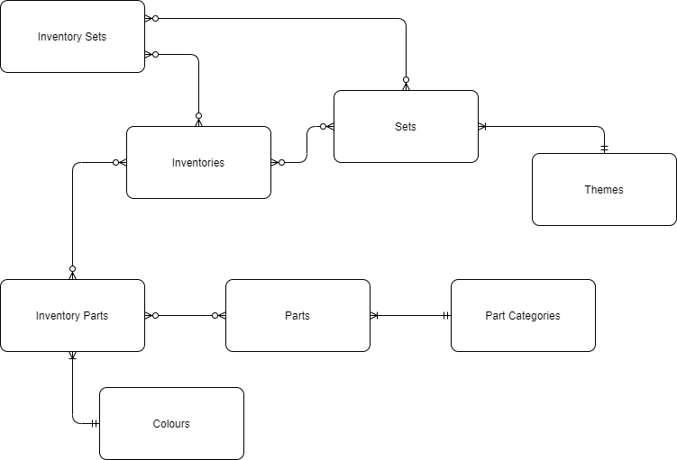

**Logical Model**

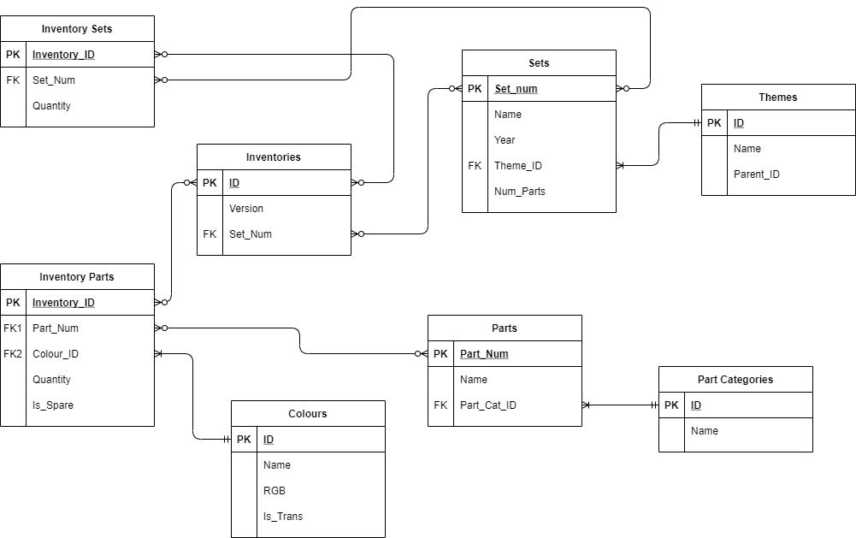

**Physical Model**

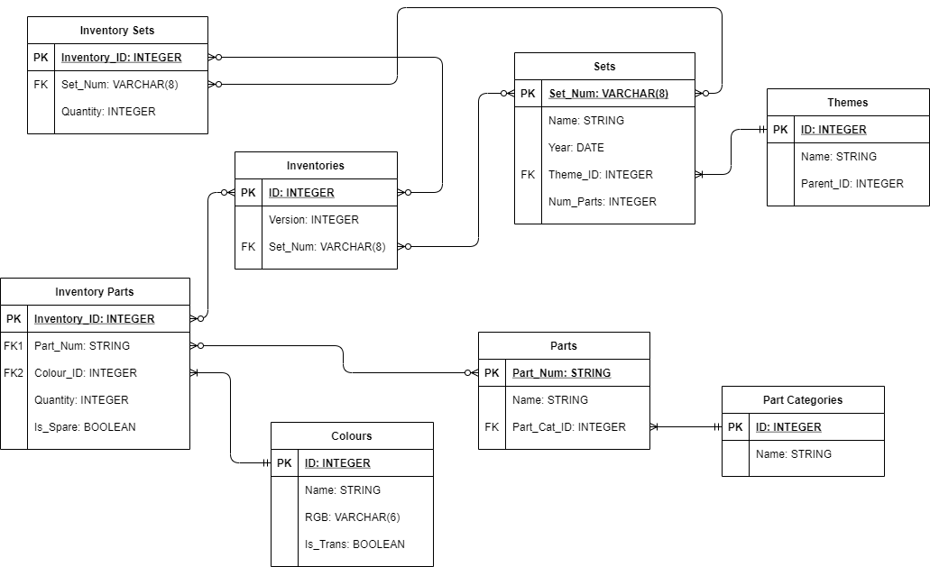

**Review**

* Think about developing the Physical model more to develop requirements
* Could be worth exploring other normal forms – especially 4th normal form
* Take out the Primary Keys and Foreign Keys from the Logical model – just include the different attributes.

Refer to: <http://www.agiledata.org/essays/dataModeling101.html>